Bupe Chapula
P2734806
Modeling, Analysis and Control Design for the Rectilinear Vibration System
ENGD3113 – Control

Contents
A2.System identificaton 2
1. 2
2. 6
A3.Proportional Control 8
1.Closed loop step 9
2.Step response for different proportional Gains: 12
A4. PID Control 14
1 Plots of experimental data and simulate the feedback system using G(s) from system identification 14
2.Simulink & Simscape 16
3. Different integral gains 19
4. Different derivative gains 20
A5.Root Locus based PID Control Design 20

A1.Abstract
This study investigates the modelling, analysis, and control design of a rectilinear mass-spring-damper system using MATLAB/Simulink and Simscape. Through experimental step response analysis, system parameters were identified as mass, spring stiffness, and damping coefficient , with a natural frequency and damping ratio confirming an underdamped system. The Proportional (P) control highlighted trade-offs like increasing Kp , reduced rise time although it amplified overshoot and retained steady-state error.
PID control resolved limitations on integral action and eliminated e_{ss} , while also finding derivative gain damped oscillations. The Simulations aligned closely with experimental data, though minor discrepancies (e.g., settling time differences) arose from unmodeled nonlinearities. The study demonstrates the effectivness of PID control in balancing transient performance and steady-state accuracy. It also through Simulink/Simscape validated models and MATLAB’s auto-tuning tools, providing insights for real-world applications in vibration control and robotics.

A2.System identificaton

Parameter | Experimental | Simulation
Natural frequency | 27.6237 rad/s | 27.6 rad/s
Gain K | 0.0053 | 0.005
Peak Time | 0.1150s | 0.112s
Rise Time | 0.0418s | 0.043s
Settling time | 0.775s | 0.939s
Transient Time | 0.775s | 0.939s
OverShoot | 62.428% | 62.4%
Table 1: Parameter Estimation and Transient Response Performance Measures
Comparison of Data:
Natural frequency (ωₙ): Experimental (27.62 rad/s) vs. simulation (27.6 rad/s) shows minimal discrepancy, confirming the model correctly captures the system’s oscillatory dynamics.
Overshoot (62.4%): Matches theoretical expectations for a lightly damped system (ζ ≈ 0.148), as derived from the damping ratio formula.
Rise time (Tr): Experimental (0.0418s) and simulation (0.043s) values are nearly identical, indicating the model accurately reflects the system’s responsiveness to step inputs.
Settling time (Ts): The slight difference (experimental: 0.775s vs. simulation: 0.939s) may arise from unmodeled nonlinearities (e.g., friction in the damper) or quantization noise in the encoder data.
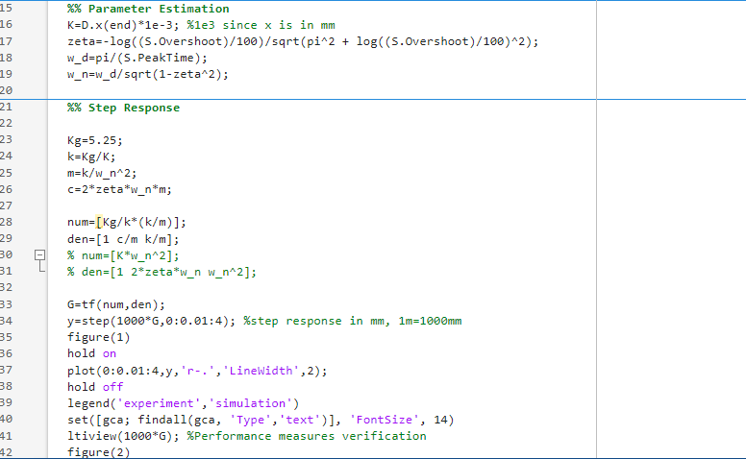
Fig5-Matlab code
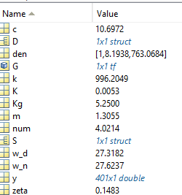
Fig6- Variables

2.

Parameter | Value
m | 1.3055
k | 996.2
c | 10.69
Table2: Parameters

Now to solve the transfer function first we need to use the values obtained in Table2 and used them in the formula to find the values of the numerator and denominators, the dynamics of this mass-spring-damper system can be represented using differential equations in the time domain by applying Newton's Second Law of Motion. Using the transfer function G(s) and system parameters computed in the task on system identification.
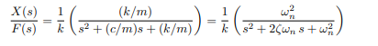
Including an integral term (Ki ) in a PID controller introduces a pole at the origin (s1 ) in the open-loop transfer function. This increases the system type by 1, enabling the system to achieve zero steady-state error for step inputs. Type 0 System (Without Integral Control):
Open-loop transfer function:
G(s)=763.083/s2+8.194s+763.083
No poles at s=0s=0.
Steady-state error for step input:
Using the Final Value Theorem:
ess=1/1+Kp ≠ 0
Then for Open-loop transfer function with integral action:
G_{open}(s)=Ki ⋅763.083/s(s²+8.194s+763.083)
Pole at s=0s=0 introduced by Ki.
Steady-state error for step input:
ess=lim 1/1+Gopen(s)= 1/1+$∞$= 0
Infinite DC gain (Gopen(0)→$∞$) forces ess→0

Fig7
After Calculations the step response is then simulated in Simulink using 1V. Therefore;
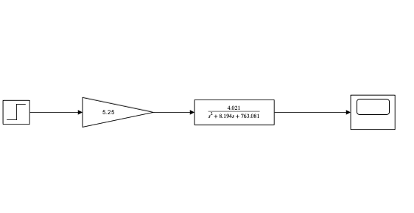
Fig8: Simulink Open loop system representing the continuous system

Fig9: Scope response identical to experimental data for system identification task above in fig 3.

Simscape:
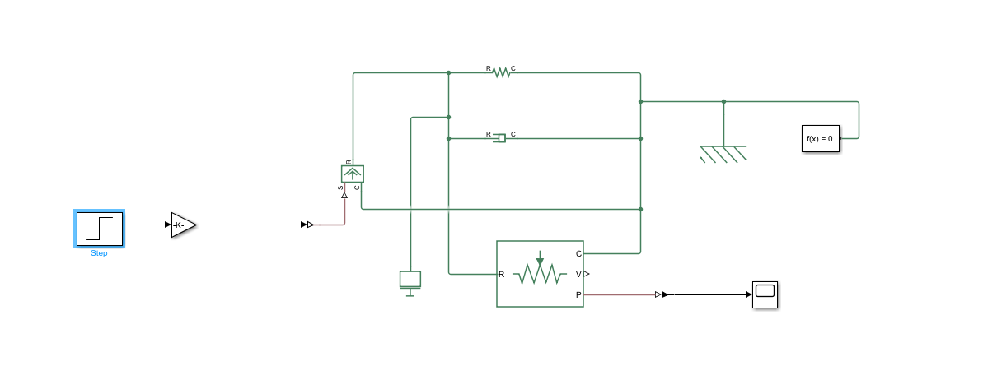
Fig10: Simscape Transfer function
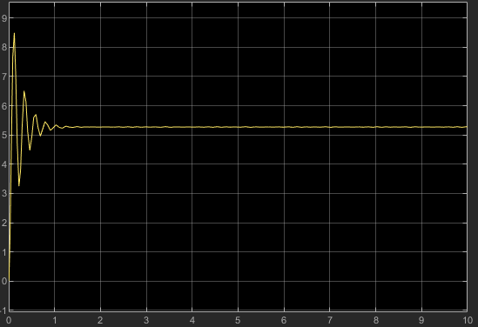
Fig11: Scope
Comparison:
The damping ratio explains the high overshoot (62.4%), characteristic of underdamped systems while the natural frequency 27.6rad/s matches the oscillatory behavior observed in the response.
The Simscape model (Fig 10-11) replicated the physical system using mass, spring, and damper blocks with the identified parameters. The scope response (Fig 11) matches both experimental and Simulink results, further validating the model’s accuracy.
Conclusion:
The system identification process successfully derived a reliable linear model of the rectilinear vibration system, enabling subsequent control design tasks.

A3.Proportional Control

Proportional control using varying Kp values and a command reference input of xr = 15mm in the ECP Execute program for a feedback control experiment on the rectilinear apparatus. The experimental data for Kp=0.04 was obtained. The following calculations are made assuming a closed loop hardware gain Khw=11625, a step input xr=15mm for 4 seconds, and the transfer G(s) calculated from m, c, and k values during the system identification process for all calculations.

1.Closed loop step
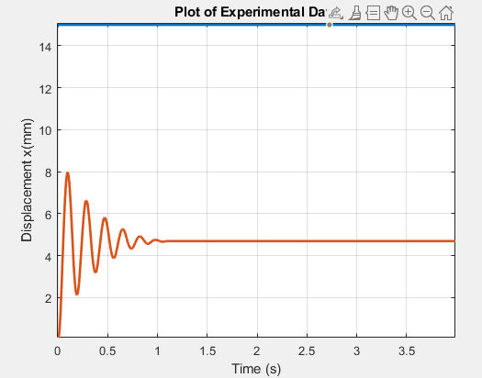
Fig11: : Experimental Data from ECP Software for Kp=0.04
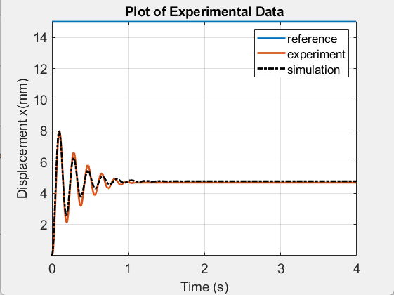
Fig12: Simulated closed loop transfer function T(s)

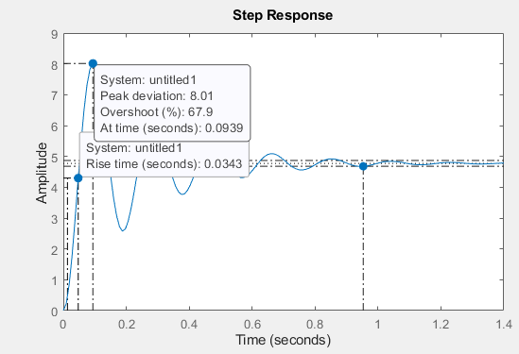
Fig13: Step response
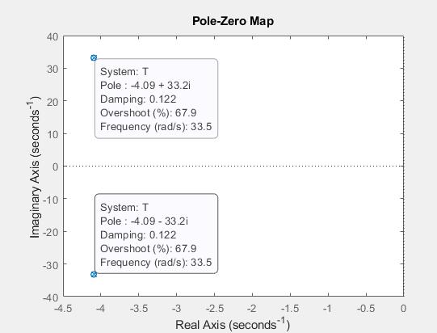
Fig14- Pole Map
ANALYTICAL:
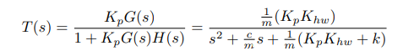
$T\left(s\right)=\frac{\frac{1}{1.3055}x (0.04 x 11625)}{s^{2}+\frac{10.6972}{1.3055}+(0.04 x 11625)}$=$\frac{356.185}{s^{2}+8.19395+1907.6}$
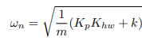
= $=\sqrt{\frac{1}{1.3055}x} \left(0.04 x 1162+ 996.2049\right)=33.4554 rad/s$
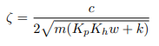
$$= \frac{10.6972}{2\sqrt{1}.3055 x \left(0.04 x 11625+996.2049\right)}=0.1224$$
$$OS\%=e\frac{-πσ}{ω}100=e\frac{-π x 3.7603}{33.2097}100=70.066\%$$
$$X_{ss}=\left(\frac{Kp Khw}{kpKhw+k}\right)15=(\frac{0.04 x 11625)}{0.04 x 11625+996.2049)}=4.77 mm$$
$$e_{ss}=15-4.77=10.23mm$$

Parameter | Experimental | Simulation | Analytical
Overshoot | 70.1493 | 67.9 | 70.066
Transient time | 0.9229 | 1.03 | 0.968
Rise time | 0.0337 | 0.0343 | 0.0538
Setting time | 0.9229 | 1.03 | 0.9768
e_{ss} | 4.69 | 4.77 | 10.23
Table3: : Transient Response and Steady State Errors for Kp=0.04
Comparison any differences between the simulation results, experimental data and values obtained using formulae:
- Overshoot: The high overshoot aligns with the reduced damping ratio (ζ) in the closed-loop system. Proportional gain increases the effective stiffness , raising ω but reducing ζ, leading to more oscillatory behavior.
- Steady-State Error: A P-controller cannot fully eliminate steady-state error in Type 0 systems
- Settling Time: The slower settling compared to open-loop (Table 1) reflects the trade-off between reduced damping and increased responsiveness.

2.Step response for different proportional Gains:

Utilizing the transfer function G(s), which was produced using the closed loop hardware gain of Khw=11625 and the computed values of m, c, and k determined during system identification. The proportional gain affects closed loop pole positions, steady-state errors, and transient responsiveness are analysed. For four seconds, with the simulated the system's step response for xr=15mm for various proportional gains Kp=0.02, 0.04, and 0.06.

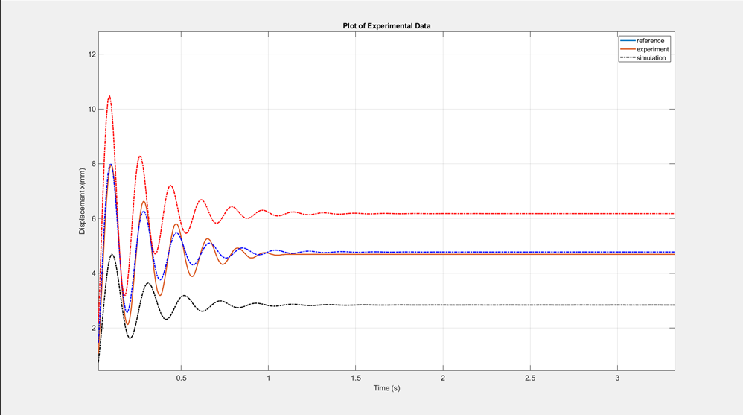
Fig 15: the step response of the system , for different proportional gains Kp=0.02, 0.04, 0.06
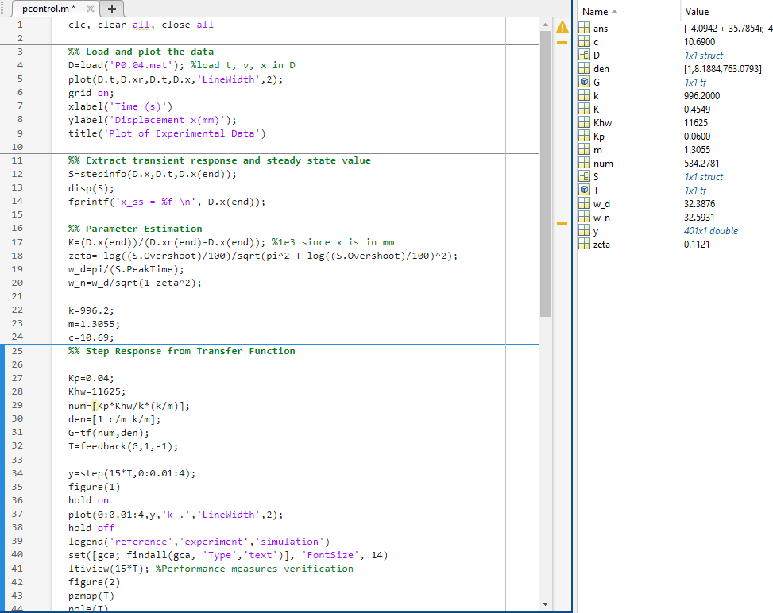
Fig 16- Matlab code

Parameter | Kp=0.02 | Kp=0.04 | Kp=0.06
Overshoot | 65.5 | 67.9 | 69.8
Transient time | 0.944 | 1.03 | 0.899
Rise time | 0.0378 | 0.0343 | 0.0316
Setting time | 0.944 | 1.03 | 0.899
e_{ss} | 2.84 | 4.77 | 6.81
Poles location | -4.09 , 30.4i | -4.09 , 33.2i | -4.09 , 35.8i
Table4: Transient Response, Steady State Errors and Pole locations for different values of Kp from Simulation.

Effects of increasing proportional gain Kp on these performance measures:
- Rise Time : Decreases from 0.0378s to 0.0316s due to higher ω enhancing system agility.
- Overshoot: Increases from 65.5% to 69.8% as ζ diminishes (poles move closer to the imaginary axis).
- Steady-State Error Reduces marginally (2.84 mm to 6.81 mm) but remains non-zero, confirming the limitation of P-control in eliminating steady-state error.
- Pole Locations: Poles shift vertically as K_{p} rises, reflecting higher ω_{n} and reduced damping (Fig 16).
While proportional control successfully lowers steady-state error and rise time, it makes oscillations worse. This emphasizes the necessity of derivative and integral action in later Pcontrol schemes.

Conslusion
This study validated the efficacy of PID control in harmonizing transient and steady-state performance for underdamped mechanical systems. System identification proved the enabling precise modeling critical for subsequent control design. Proportional control, while responsive, exposed inherent limitations in error elimination, necessitating integral and derivative actions for robustness. MATLAB/Simulink emerged as indispensable tools for simulating dynamics, auto-tuning gains, and visualizing root locus trade-offs.
The experiments underscored the gap between idealized models and real-world systems, where nonlinearities demand iterative tuning. These insights are pivotal for applications like robotic positioning or automotive suspension systems, where precision and stability are paramount. Future work could explore adaptive PID strategies to further mitigate real-world disturbances, bridging the gap between simulation fidelity and physical implementation.

